Managers Adding a Member Profile Note
Before You Start
- Notes entered in the Private Note field are visible to Managers but are not visible to the family.
- There is not any restriction on which level of Manager may see the profile note. Notes added by Institution Managers may be seen and modified by County Managers that have access to the Member Profile, and vice versa.
- Only the Manager that created the member profile note may delete it.
- If the Send Email box is marked, the family will receive an email notification that the member profile has received a comment. The text of the Note is visible to the family in the email. The text of the Private Note is not available to the family in the email nor on the member’s profile, but they will still get an email that a comment was added.

Steps  - Click on Member in the navigation pane.  - Search and select the intended member record.  - Click on Profile in the navigation pane. | Screenshots  (Screen appearance may vary per state)
- In the Profile Notes section, click the Add button. | 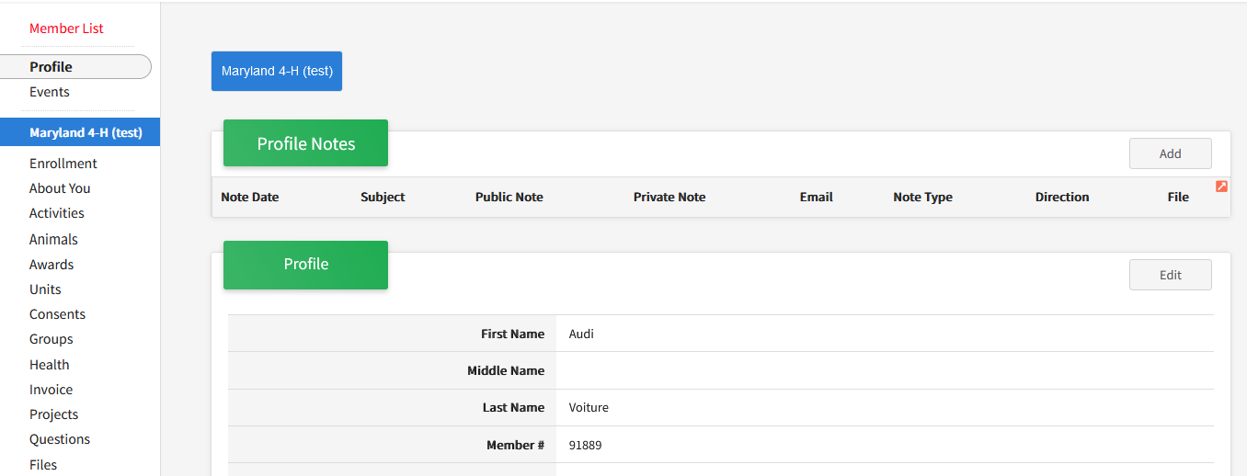
- Check the Send Email box if you want to notify the member of this note. This is not a required field; but will email the family a copy of the public note.  - In the Note Type field, select the type of note that the information was communicated. (Email, Other, Phone, Text)  - Select the direction of the note (incoming or outgoing)  - Enter the date of the note.  - Enter the subject of the note.  - If the note is to be visible to the family) enter the note into the Note field.  - If the note should not be visible to the family, enter it in the Private Note field.  - Click Save. | 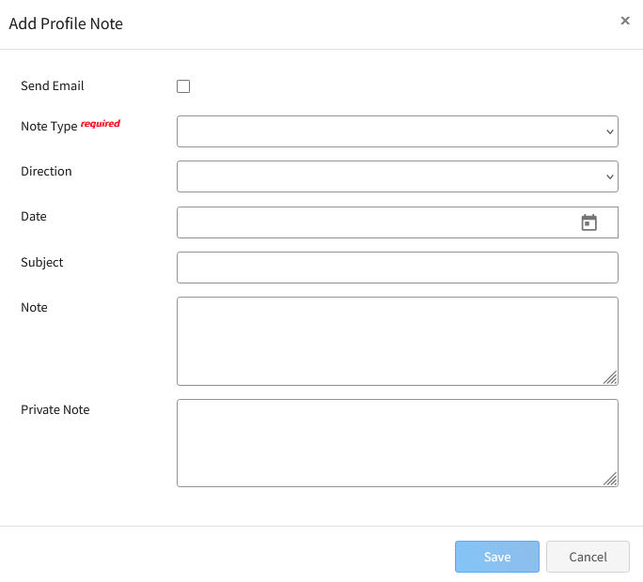
Adding a File to a Profile Note
- Files may be uploaded to a note after the note has been saved.  - Click on the note in the Member profile that you want to add a file.  - Click the Upload button.  - Select the PDF file you wish to attach to the note. The file will save automatically. | 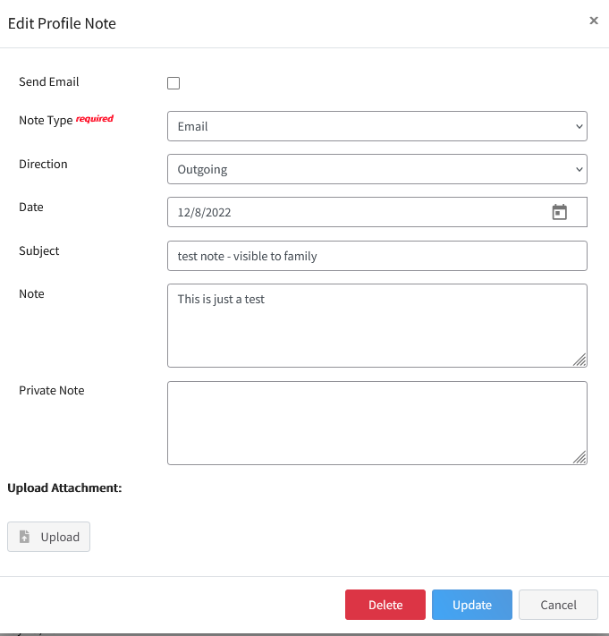
Editing a Member Profile Note
- Click on the note you wish to edit.  - Modify the text of the note and/or private note as needed.  - Click Update to save the modifications.  NOTE: Modifications to the note are not resent to the family. | 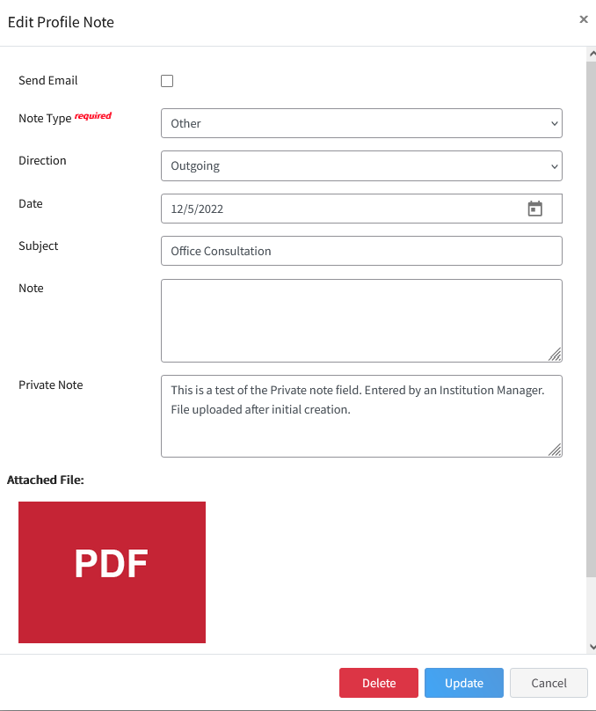
Tips
- If the profile note only contains a private comment, do not select the option to Send Email.

