Moving a Member Record to a Different Family Profile
Before You Start
This process is limited to institution managers. Be sure that you know the county, family name and family mailing address for the destination (new) family profile.
Steps  - Click on Member in the navigation pane.  - Search for the member by name and select the record.  - Click on Profile in the navigation pane. | Screenshots  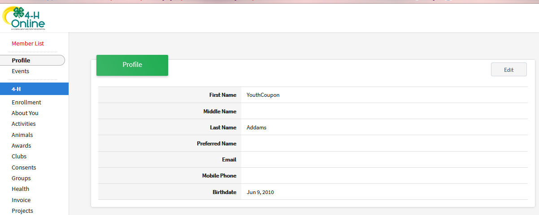  (Screen appearance may vary per state)
- Scroll to the bottom of the member profile, and in the Families section, click Move. | 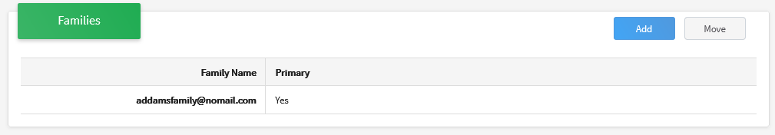
- Select the Family County for the destination family from the drop-down menu.  - Select the destination family from the drop-down menu. The family list will include the Family last name and USPS mailing address.  - Click Move. | 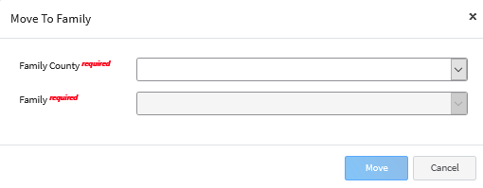
- Click Confirm to move the member to the selected family. | 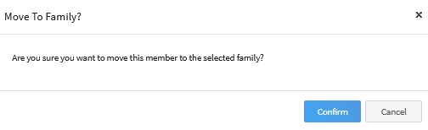
Tips
Be aware of the member’s current participation status when moving members. If the member's enrollment has been submitted but not yet approved, the Primary Club County Manager may need to return the enrollment to the new family so that the enrollment information is correct and has the proper signatures when resubmitted for approval.

