Custom Reports
Before You Start
Custom reports are designed to answer a question. Before setting up a report, you need to:
- Define the question you are trying to answer,
- Identify which records should be included on the report (examples: active members, 4th grade active members, active volunteers in XX county, etc.) and
- Select a sort order that will give you the answer you need (examples: alphabetical, by age, by years of membership, etc.).

Creating a Folder for Custom Reports
Steps  - Click on the Custom Reports tab in the navigation pane.  - Enter the name of your new folder and click the Add button. | Screenshots  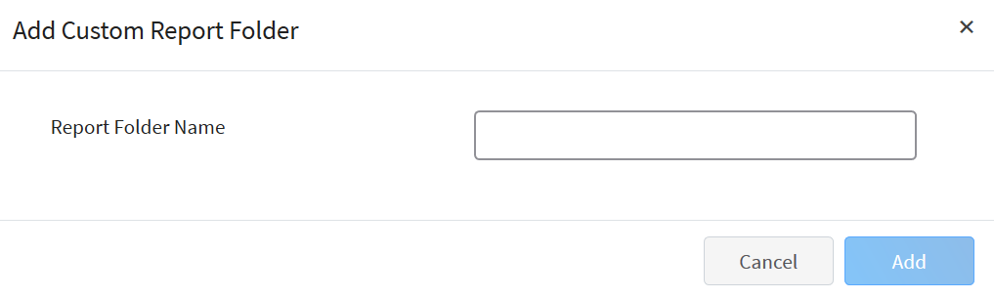  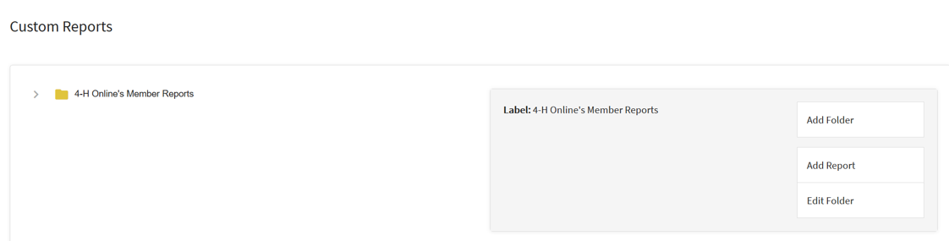  (Screen appearance may vary per state)
Creating a Custom Enrollment Report
- Click on the Custom Reports tab in the navigation pane.  - View the available list of folders.  - Click on the folder title in which you want to add your new report.  - Click Add Report to create a new report in the selected folder. | 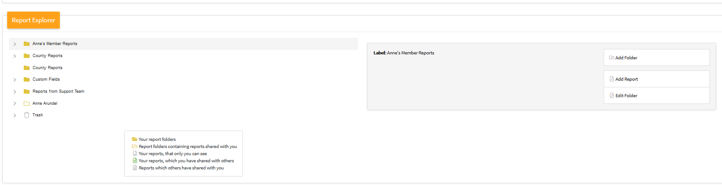
- Enter the name of your report. Do not use special characters or symbols in the Report Name to avoid errors.  - Enter a description of the report.  - Enter the name of the Excel Worksheet title. Do not use special characters or symbols in the Excel Worksheet title to avoid errors.  - Click the Add button. | 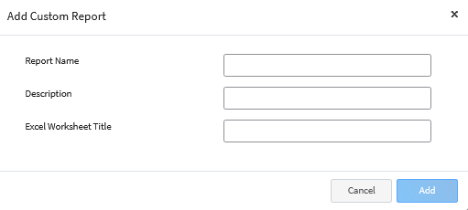
- In the Report Detail section, you may edit the name and description of your report. | 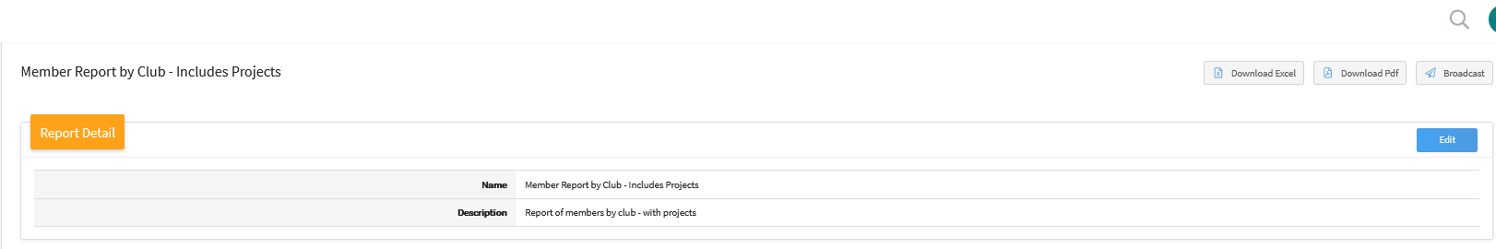
- The Target area allows you to set the program year for the report data.  - The Hierarchy drop-down menu allows you choose the area of the hierarchy for the report (within the Manager’s assigned hierarchy areas). | 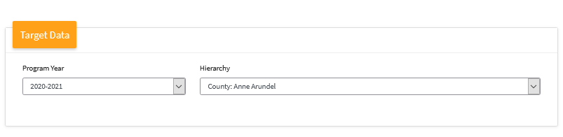
- Click Edit on the Report Columns category to begin selecting the columns (fields) to be included on the report.  - Click on the Column Category to view the available fields to include on the report. You may select columns from as many column categories as needed.  - Click on the field name and click the right arrow to add it to the report.  - Repeat step 13 – 14 for each field you need to add to the report.  - Click Save.  NOTE: The User Defined category consists of the custom fields set up for your Institution’s enrollment process. | 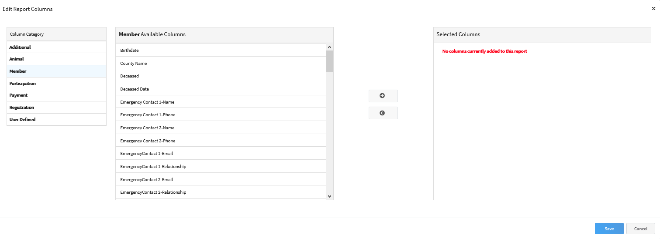  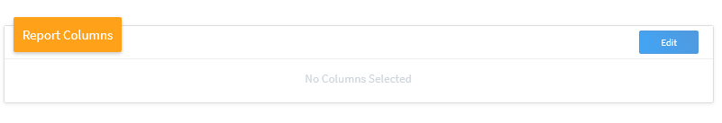
- Click Edit next to Standard Filters to add filters based on the following criteria:  - Include All Years**  - Enrollment Roles  - Member Participation Status  - Enrollment Start Date  - Enrollment End Date  - Member Flagged  - 4-H Age  - School Grade  - Family County  - Enrollment County  - Primary Units Only  - Units (County Managers only)  - Projects | 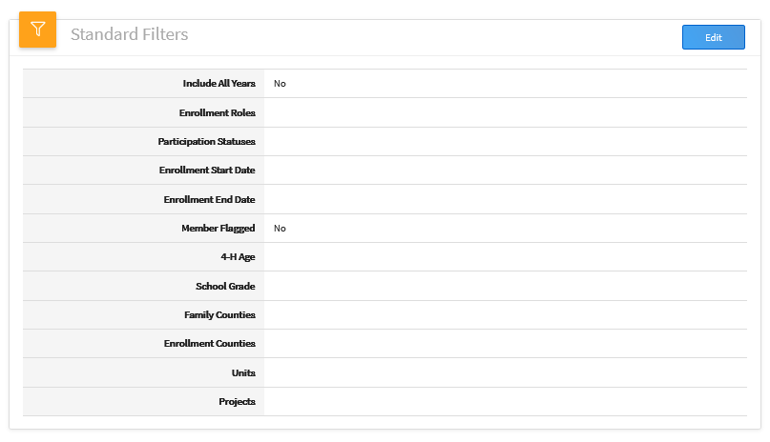

- Add additional filters not covered by the standard filters by clicking Edit next to the custom filters.  - Click the Add group button.  - Click the Add filter button.  - Select the data field you would like to filter the report on.  - Select the operator. Depending on the data field you are filtering on, the operator choices may change.  - You may add more than one filter to the group if needed. If the records returned need to match all of the filters within a group, use the AND option between each data field. If the records need to match any one of the filters in the group, use the OR option between each data field.  - For complex filtering, you may also add multiple groups of filters. Again, use the AND between groups if the records must meet the criteria of both groups of filters. Use the OR between groups of filters if the returned records need to only match the criteria of one of your filter groups.  - Once you have entered all your custom filters, click Save.  NOTE: The standard filter for “Include All Years” will give you a report that has multiple lines for the member if they have participated in more than one program year. Using this filter removes all program year specific filters. The Member Participation Statuses are based on a specific program year, so do not use the Participation Statuses filters if you are going to use the “Include All Years” standard filter. | 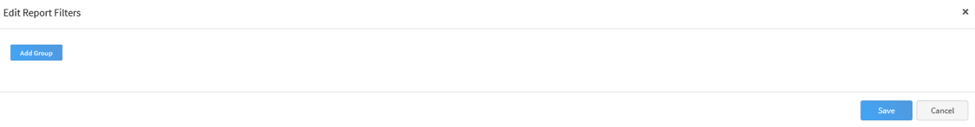  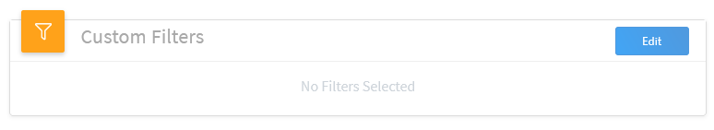  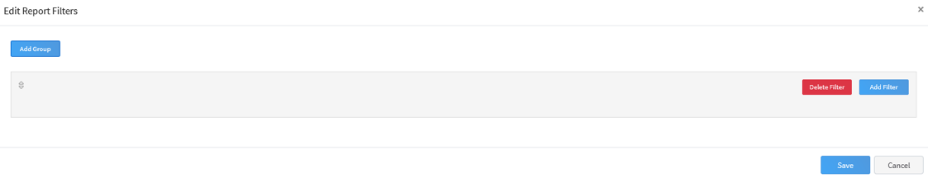  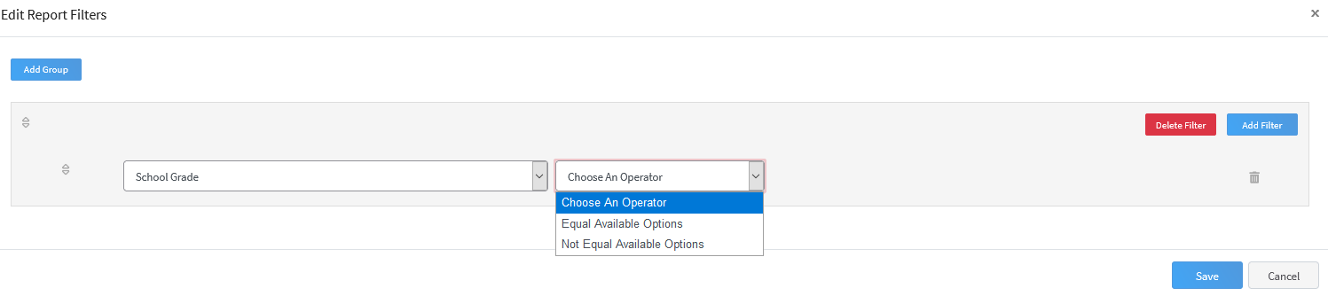  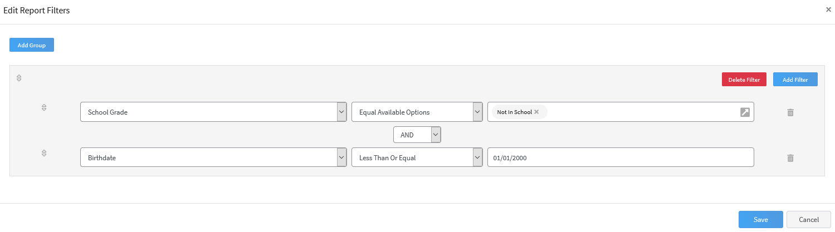
- To sort the report results based on specific columns, click the Edit button.  - Click the Add Sort button.  - Select the column to use as the primary sort.  - Select the radio button to sort the records in ascending or descending order.  - Add additional sort columns if needed. Multiple sorts will work “in order”: If you specify County followed by Grade, all of County A records will be listed first, by grade; then County B by grade.  - Click Save. | 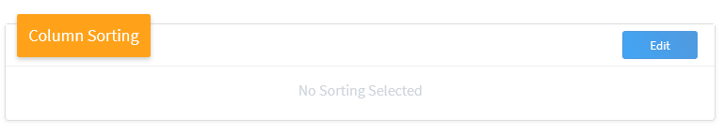  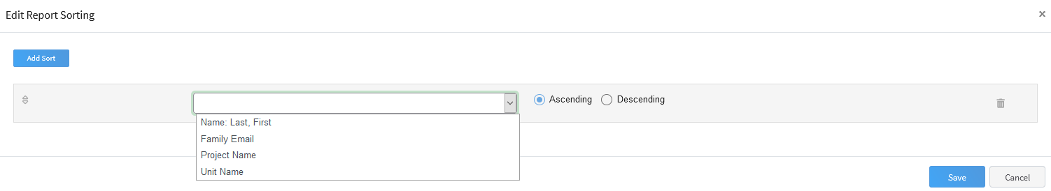  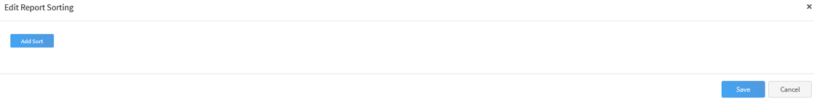

- To group records together, for page breaks or counting purposes, you can set the grouping fields. Click Edit to setup your groupings.  - Use the drop-down menu to change the grouping type (column grouping or row grouping).  - Click the Add Group button.  - Select the data field to use as the grouping.  - Check the Hide Column option if you do not want to see the data for this field, but it is used as a grouping option.  - Check the Page Break option, to insert a page break into the PDF format of the report after each unique grouping field.  - Check the Record Count option for the records within the group to be totaled on the report.  - Add more grouping fields if needed by repeating steps 34 – 38.  - Click Save. | 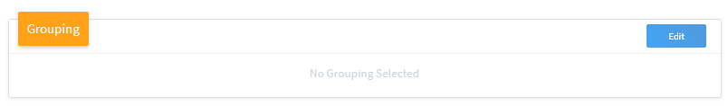  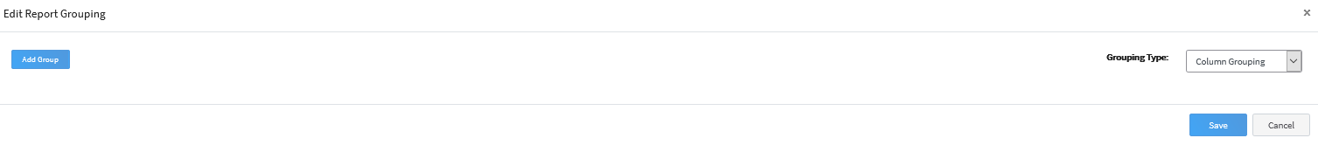  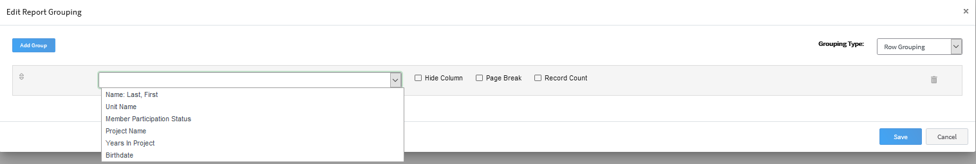
- If you have made changes to the report that are not reflected in the Preview, click the ‘Refresh’ button. The Preview of the report will refresh the returned results.  - Use the arrow buttons to preview additional returned records. | 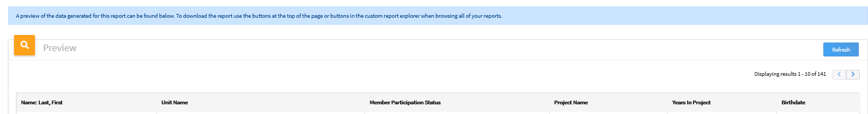
- Return to the top of the screen to select the report output format. Download an Excel file or PDF file, or send a broadcast email to the member records returned on the report.  NOTE: Hidden Columns, Page Breaks and Record Grouping and Counting totals are only displayed on the PDF format of the report. They are not included in the report preview or the Excel format. | 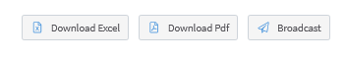
Editing Custom Reports
- Custom reports can be edited at any time.  - Click on the folder that contains the report to be edited, then click on the report title.  - Select the ‘Edit Report’ option from the menu on the right side of the screen.  - Once in edit mode, you may change columns, order, filters, sorting, and grouping.  - After saving changes, click the Refresh option on the report preview to display changes. | 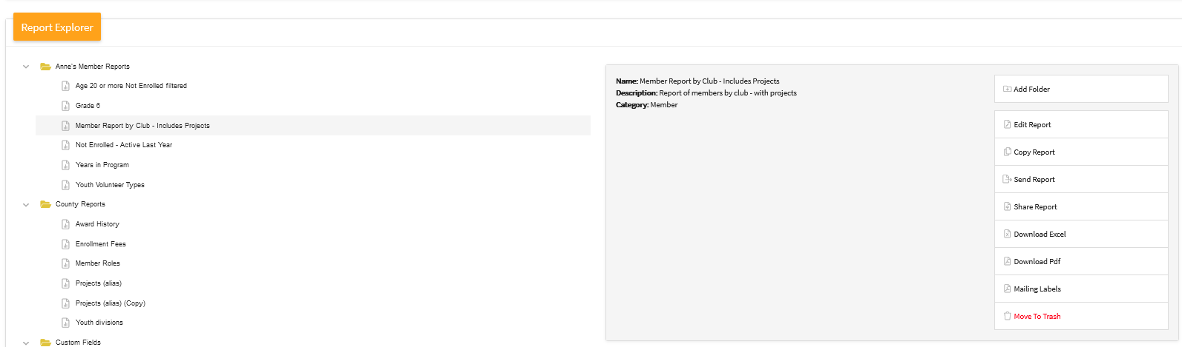
Copying Custom Reports
- You may copy an existing custom report to use as a starting report for additional reports.
- Select the folder that contains the report you wish to copy, and click on the name of the report to be copied.
- Click the Copy Report option from the menu on the right side of the screen.
- Click on the report designated with the (Copy) appended to the report name to edit it.
- Select Edit Report from the menu on the right side of the screen.
- Click the Edit button for the Report Detail to rename the report.  - Edit the report columns, filters, sorting and grouping options as needed. | 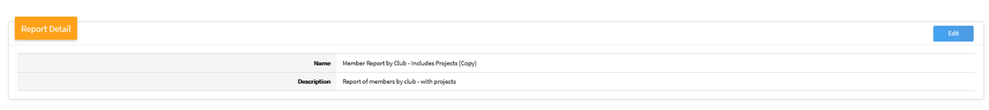
Sending Reports
- Reports may be sent to another manager. The other manager will be able to modify the report as needed, as if they created it.
- Click on the folder containing the report you wish to send to another manager, then on the report.
- Click the Send Report option in the menu on the right side of the screen.
- Enter the manager’s email address or name, and select the account from the drop-down menu.  - Click the Select button.  NOTE: The receiving manager will have a folder created in their custom report area titled “Reports from X County” where X is the name of the county that sent the report. This folder will contain the report, and the receiving manager will be able to edit that report as necessary. | 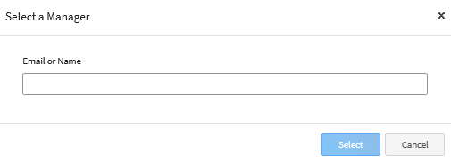

Sharing Reports
- Managers may share reports with other managers, while retaining authorship of the report. Click on the name of the folder containing the report you wish to share.
- Click on the name of the report you wish to share.
- Select Share Report from the options menu on the right side of the screen.
NOTES:
- Managers may share reports with other managers, while retaining authorship of the report. Shared reports may not be edited by receiving managers. The shared report may be copied and then edited, but the report will remain in the Shared folder.
- Shared reports are shared across and down the hierarchy: Reports shared by an Institution Manager will be shared with other Institution Managers and County Managers. Reports shared by County Managers will be shared with other managers in their county.
- If a shared report is modified by the creator, those changes will be reflected for all managers that have access to the report.
- Custom Reports cannot be shared with Club Leaders, as they do not have access to custom reports.

Mailing Labels
Managers may print mailing labels for each member or family represented on a Custom Report.  - Click on the title of a report.  - Click on “Mailing Labels.”  - Select to print mailing labels for the Family or for the Member address. If Family is selected, one mailing label will print for each family represented on the report. If Member address is selected, one mailing label will print for each member represented on the report.  - If you would like the mailing labels to start at a cell other than the first cell on the page, select how many labels you would like to skip before the first label is printed.  - Select options: Apply Upper Case, Include ‘Or Current Resident’, remove the comma between City and State or Sort by Zip Code.  - Click “Download” and then select to save or open the mailing labels. | 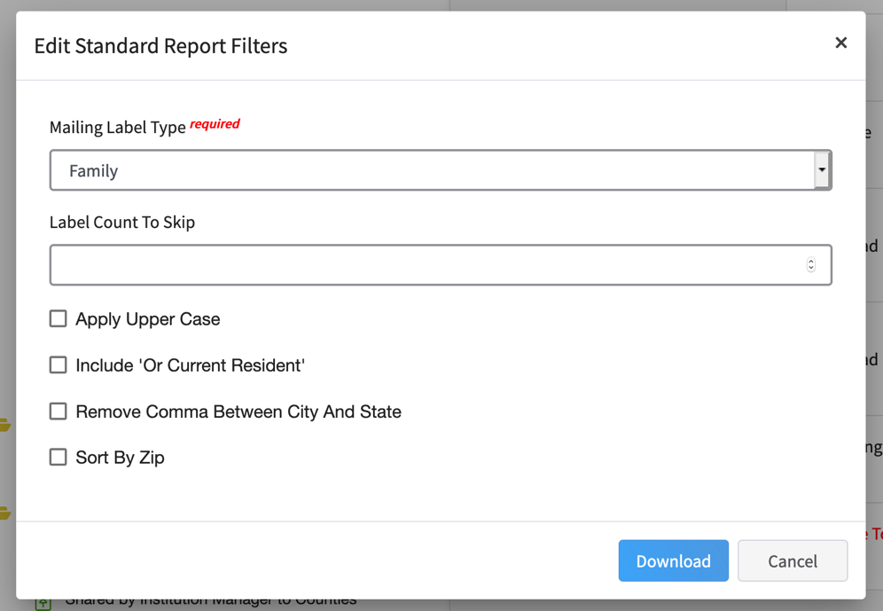
Tips
If an Institution manager is running a report that contains a large amount of data, causing it to take longer than usual to load, the manager will receive a message that the report is being queued. The manager will receive an email when the queued report is ready and may download the completed report from the “Queued Reports” section at the top of the Custom Reports page.

