Changing Payment Method After Declined Payment
Before You Start
Changing the payment method is only permitted when the credit card payment has been declined.
Families may attempt to pay with the same or different credit card, or may change the payment method to be a check to pay to the County or State 4-H office as directed.
Steps  - Log in to 4-H Online with your family’s email address and password.  - On the Member list, click View next to the member’s name.  - Click on Events in the navigation pane.  - Click on the Approved event registration for which the payment was declined.  - Scroll to the Invoice portion of the event registration. The Invoice must indicate it is still Payable.  - Click the Pay By Check button.  - Click the Confirm button to change the payment to Pay By Check.  - Submit your payment to the County or State 4-H Office as directed. | Screenshots  (Screen appearance may vary per state)  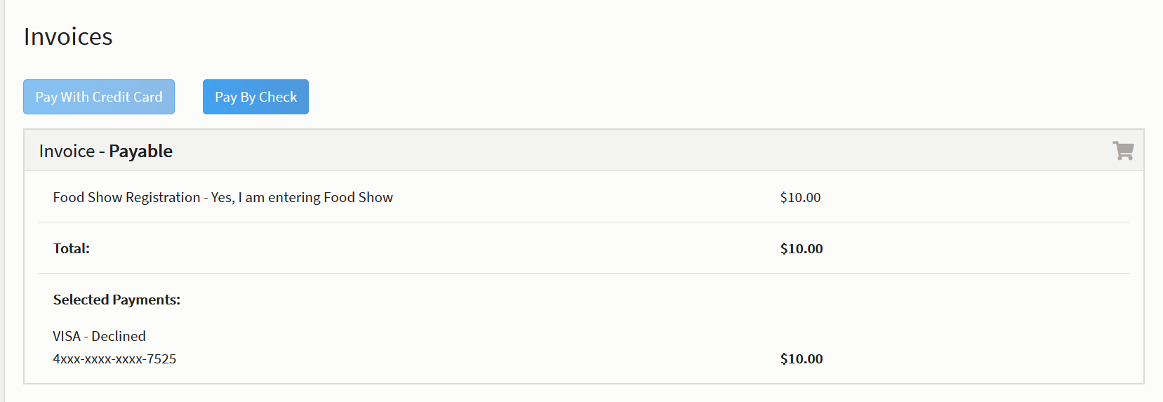  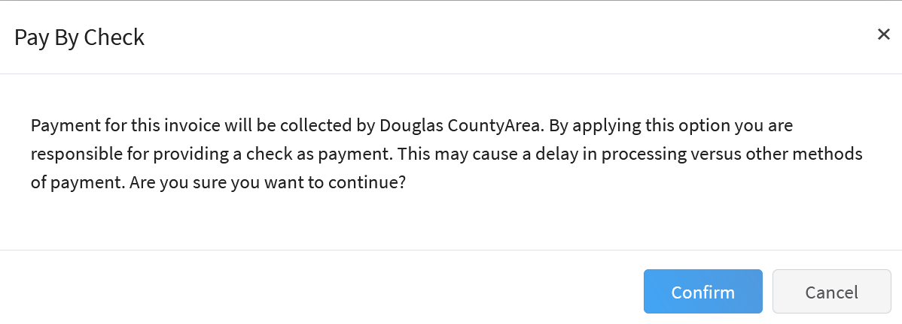
Tips
If you have questions, please contact your local Extension Office for assistance.

