 | Simulated Effects of Tile Drains on Recharge
 | 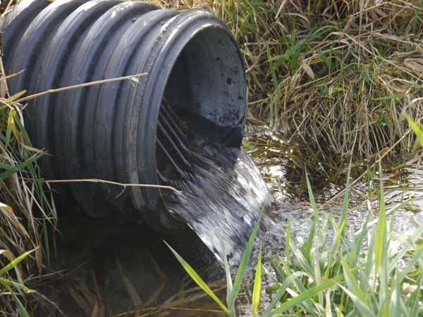
6/30/2016 |  | Modeling impacts in the Saginaw Bay Watershed
 | This report discusses the results of the hydrologic model HYDRUS utilized to simulate the impact of agricultural tile drainage on rates of groundwater recharge in the Saginaw Bay Basin. These impacts were incorporated into previous efforts to model groundwater recharge with the Soil and Water Assessment Tool (SWAT), and made available through the online GLWMS.

Simulated Effects of Tile Drains on Recharge

Modeling impacts in the Saginaw Bay Watershed

Overview
The Great Lakes Watershed Management System (GLWMS) utilizes the Soil and Water Assessment Tool (SWAT) to predict change in groundwater recharge via land cover or conservation practice changes on a field scale basis in the Saginaw Bay Watershed (SBW). SWAT uses a simplified process-based approach with lumped-parameters to simulate water fluxes to tile drainage and recharge to groundwater. Values of the lumped parameters are generally unknown and are difficult to estimate accurately due to natural vertical stratification of soil layers and high spatial variability in soil properties. Inaccurate values of the lumped parameters commonly result in poor prediction of drainage and groundwater recharge fluxes. SWAT requires users to define an impervious sub-surface layer below the tile in order for water to pond in the soil profile, reach the tile, and then discharge to the stream network. This design effectively eliminates recharge to the shallow aquifer, which is an unlikely outcome. Due to the extent of tile drainage on agricultural lands in the SBW and those tiles having significant impact on recharge, a physically based modeling approach with distributed parameters should be used to estimate recharge in tile drained fields. HYDRUS, which uses a physically-based modeling approach with distributed parameters, describes more accurately water fluxes in partly saturated heterogeneous soils and accounts for the spatial variability of soil properties.

The Institute of Water Research has integrated SWAT and HYDRUS to model the impacts of tile drainage on recharge. Outputs from the existing SWAT model produced for the SBW were used as inputs for the HYDRUS model. Numerous simulations were run using HYDRUS to produce tabular outputs of recharge impacts under a variety of scenarios. The HYDRUS model outputs were used to calibrate and validate a Neural Network, which were coupled with the SWAT model to correct SWAT computed values of recharge for all rainfall events, and evaluate accurately percent changes of recharge on tiled vs non tiled fields. These percent changes were applied to outputs from the SWAT model in the GLWMS. Users interested in recharge on the GLWMS will apply a conservation practice or cover type change on a parcel of land and indicate via a check box whether the parcel of land is tile drained. The GLWMS will then collect site specific information such as soils, slope, conservation practices/cover types, etc. in real time and pass those inputs to a look-up table of SWAT simulation outputs. The look-up table will provide estimates of recharge changes based on tile drainage under the indicated conditions and correlated HYDRUS results.

HYDRUS 3D Description
HYDRUS, is a general software package for simulating water, heat, and solute movement in two- and three- dimensional variably saturated media. The software package consists of the computation computer program, and the interactive graphics-based user interface. The HYDRUS program numerically solves the Richards equation for saturated-unsaturated water flow and the convection-dispersion equation for heat and solute transport. The flow equation incorporates a sink term to account for water uptake by plant roots. The heat transport equation considers transport due to conduction and convection with flowing water.

The solute transport equations consider convective-dispersive transport in the liquid phase, as well as diffusion in the gaseous phase. The transport equations also include provisions for nonlinear nonequilibrium reactions between the solid and liquid phases, linear equilibrium reactions between the liquid and gaseous phases, zero-order production, and two first-order degradation reactions: one which is independent of other solutes, and one which provides the coupling between solutes involved in sequential first-order decay reactions. In addition, physical nonequilibrium solute transport can be accounted for by assuming a two-region, dual-porosity type formulation which partitions the liquid phase into mobile and immobile regions. Attachment/detachment theory, including the filtration theory, is included to simulate transport of viruses, colloids, and/or bacteria.

The program may be used to analyze water and solute movement in unsaturated, partially saturated, or fully saturated porous media. HYDRUS can handle flow regions delineated by irregular boundaries. The flow region itself may be composed of nonuniform soils having an arbitrary degree of local anisotropy. Flow and transport can occur in the vertical plane, the horizontal plane, a three-dimensional region exhibiting radial symmetry about the vertical axis, or fully three-dimensional domain. The water flow part of the model can deal with prescribed head and flux boundaries, boundaries controlled by atmospheric conditions, free drainage boundary conditions, as well as a simplified representation of nodal drains using results of electric analog experiments. The two-dimensional part of this program also includes a Marquardt-Levenberg type parameter optimization algorithm for inverse estimation of soil hydraulic and/or solute transport and reaction parameters from measured transient or steady-state flow and/or transport data for two dimensional problems.

Groundwater recharge from agricultural fields can be modeled using the HYDRUS-3D software. To do that, a project that includes material distribution and boundary conditions for each area of concern (e.g. fields with tile drainage) should be generated based on DEM, land use, and soil map used in the SWAT project. HYDRUS-based modeling includes the following steps:
1. Generating simulation mesh
2. Estimating the soil hydraulic properties
3. Setting the initial and boundary conditions
4. Model run
5. Result analysis

Methods and Results
Since it is impractical to couple HYDRUS with SWAT model, HYDRUS was used as a standalone module to generate drainage and recharge fluxes on event base for multiple soil, crop, slope, weather and drainage scenarios as shown in Fig. 1. The modeling results combined with input data were used to calibrate and validate a Neural Network (Matlab Neural Network Toolbox). Compiled Matlab code was integrated into the SWAT-based framework to estimate recharge and drainage fluxes based on area selected in the SWAT project model for specific rainfall events and water contents in soil profiles.

To facilitate integration with SWAT, each HYDRUS model was set up using the same land cover dataset (USDA Cropland Data Layer) and soils layer (USDA SSURGO) as the original SWAT recharge models. For each 8-digit watershed, a HYDRUS model in which all agricultural fields were tile drained was generated, and another was generated in which those fields were not tiled. For each model, annual recharge between 2001 and 2010 was averaged by a combination of land cover class and hydrologic soil group (e.g. corn on soils in the B hydrologic group). For each unique combination within a model, a percentage reduction in recharge under a tiled condition was calculated (e.g. [RechargeCorn-B-Untiled – RechargeCorn-B-Tiled] / RechargeCorn-B-Untiled * 100), and stored in the GLWMS database. Multiple rainfall scenarios were run in the batch mode for the same simulation mesh and soil/crop properties to generate recharge and drainage fluxes for specific rainfall events with different initial water contents in soil profiles.

Figure 1- Integrating HYDrus into swat-based watershed modeling framework

Percentage reductions varied between watersheds, mainly due to the spatial variability of soil classes. Table 1 lists the reductions averaged by hydrologic soil group across the watersheds.

Hydrologic Soil Group | Percentage Reduction in Recharge with Tile Drainage
A | 20.6
B | 21.4
C | 21.8
D | 9.6

Table 1 - Reductions in recharge by hydrologic soil group, averaged across the 8-digit watersheds of Saginaw Bay Basin.

Integration into GLWMS
An option to simulate tile drainage was then added to the GLWMS’ field-scale recharge analysis window (Figure 2). Selecting this option prior to running a recharge scenario instructs the system to analyze the digitized field for unique combinations of land cover, hydrologic soil group, and slope, then retrieve the recharge rates for each combination as originally modeled by SWAT; those rates are then adjusted downward for agricultural areas based upon the unique combinations of land cover and hydrologic soil group (without considering slope) by the tile reduction percentage modeled by HYDRUS. Figures 3 and 4 illustrate the effect of tile drainage on recharge in an example GLWMS scenario. In Figure 3, results for a field conversion from conventionally tilled corn to no-till with a winter wheat cover crop, without tile drainage, project an increase in annual recharge of 0.82 inches. Figure 4 reflects the same scenario, but with tile drainage included. The projected increase is 0.72 inches, a decrease of 12%.

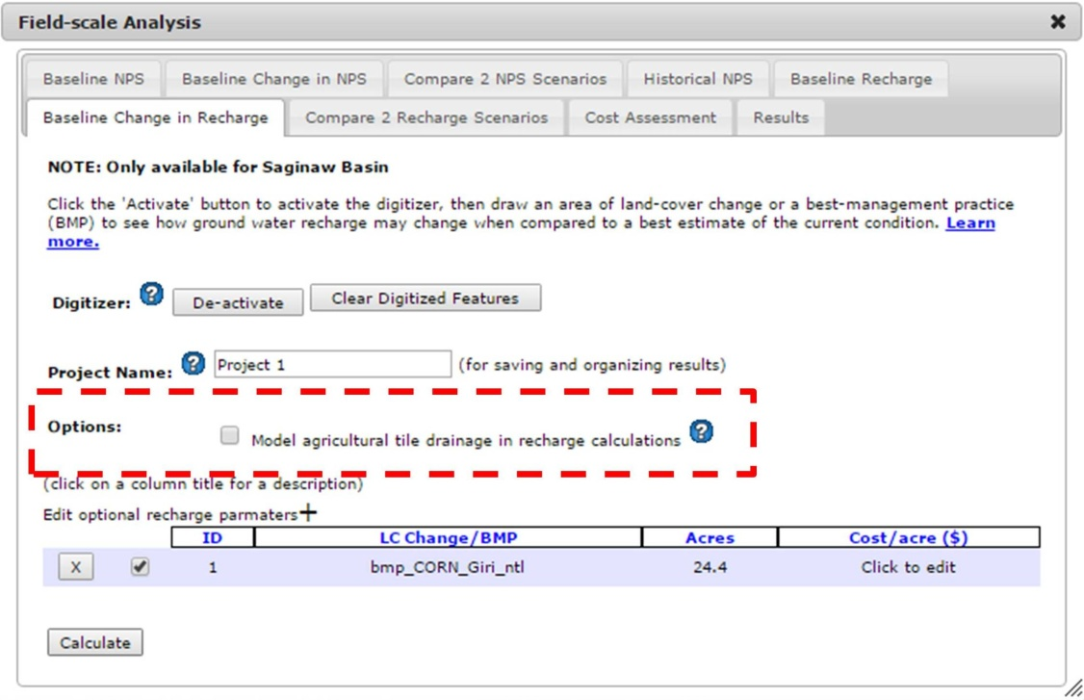
Figure 2 - Tile drainage option added to GLWMS

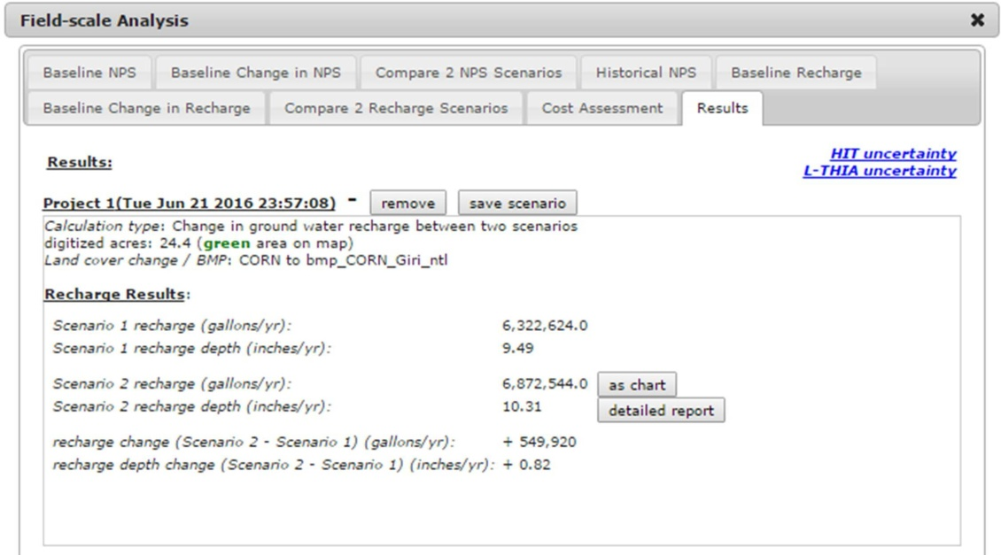
Figure 3 - GLWMS recharge results for converting from corn to corn under no-till with a cover crop, without simulating tile drainage

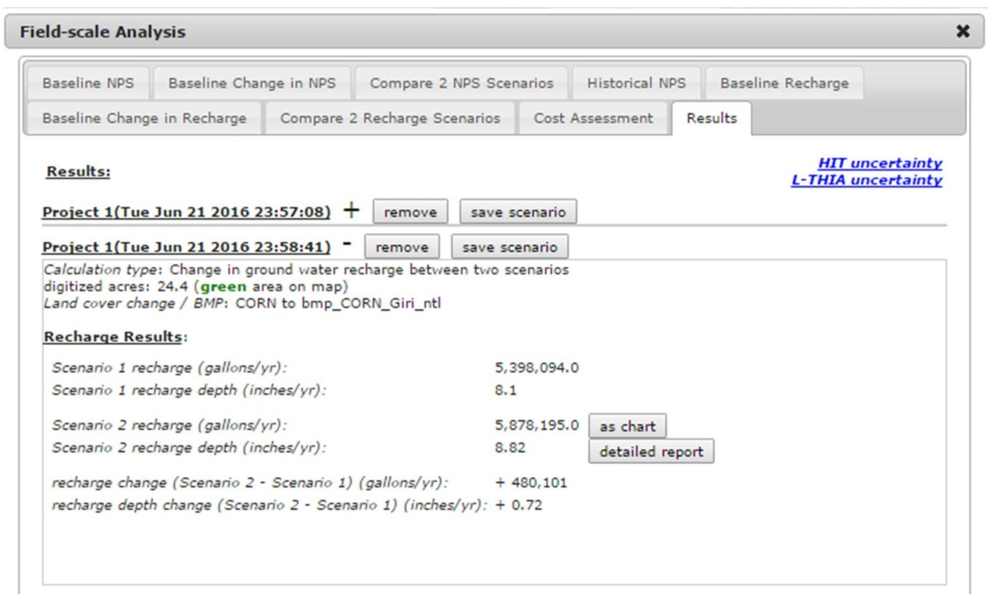
Figure 4 - GLWMS recharge results for converting from corn to corn under no-till with a cover crop, including tile drainage

GLWMS and Tile drain management simulations
IWR explored the feasibility of incorporating tile drain management as a simulated best management practice in the GLWMS. This could be accomplished in a number of ways ranging from simple to complex. The simpler approach would involve conducting a literature review to determine relationships of soil types, water volume, and other factors related to nutrient loads. This information can be built into a look-up table and incorporated into the GLWMS. Assumptions on correctly managed drainage structures would have to be assumed. A more complex method could be modeled with HYDRUS 3D or related software that could be calibrated to existing drain structures. Results from the modeling effort could then be built into the GLWMS. There would be a greater investment in both time and resources to complete a modeled simulation of tile drain management as compared to a literature review or literature review and incorporation of existing tile drain management monitoring.

Future Work
Because this project focused on Saginaw Bay, estimates for reductions in recharge in the presence of agricultural tile drainage were undersampled on sandier soils because of the prevalence of clay soils in the region. In order to produce better estimates on A and B hydrologic soils, future HYDRUS modeling should be done in areas where these soils are more typical. Additionally, future HYDRUS modeling should explore different tile drainage parameters, such as spacing, tile depth, and drain diameter. For this initial exploration in the Saginaw Bay Basin, those parameter values were held constant. More detailed modeling could potentially allow GLWMS users to define these values as opposed to simply treating tile drainage as a binary variable.

Authors

Institute of Water Research - Michigan State University
Jeremiah Asher asherjer@msu.edu
Glenn O’Neil oneilg@msu.edu

Plant, Soil, and Microbial Science – Michigan State University
Andrey Guber akguber@msu.edu

