FOR IMMEDIATE RELEASE

CONTACT Jaime Jennings, 202-232-7933x44
jjennings@islandpress.org
Katharine Sucher, 202-232-7933x43
ksucher@islandpress.org

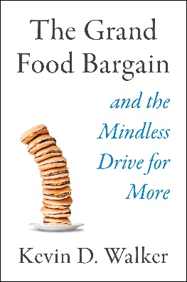
PRESS RELEASE
The Grand Food Bargain
And the Mindless Drive for More

By Kevin D. Walker

Washington, DC (March 26, 2019)—We have fashioned a country where being surrounded by unending food seems normal. When we feel hungry, we open cupboards, look in refrigerators, or stop at any number of nearby restaurants or supermarkets. Over time, this system has encouraged us to know less and less about where our food comes from and permitted us to expect more food with less effort. But this illusion of endless abundance is about to be shattered.
The Grand Food Bargain and the Mindless Drive for More (Publication Date: March 26, 2019) provides a powerful look at the global consequences of America’s modern food system. In it, Kevin D. Walker combines a lifetime of food system experience with pivotal research to craft a sweeping history of our relationship with food. The result is a stunning indictment of a system that prioritizes volume over nutrition, low costs over livable wages, and blinds consumers to harmful effects ranging from polluted rivers and food waste to obesity and disappearing species.

With this book, Walker cements himself as one of the most remarkable food writers of our time. He masterfully weaves stories of his own experiences growing up on a farm and working in agribusiness with travels around the world, from a paradigm-shifting moment in the Kalahari Desert to lessons about the global food system on a Costa Rica banana plantation.

By the end of the journey, we not only understand how the drive to produce ever more food became hardwired into the American psyche, but why shifting our mindset is essential. It starts, Walker argues, with remembering that what we eat affects the wider world.

The Grand Food Bargain will change the way you think about food across the globe and in your own pantry. Walker’s seminal book shows that if each of us decides bigger isn’t always better, we can renegotiate the grand food bargain, one individual decision at a time.

Kevin D. Walker grew up farming and has seen almost every facet of agriculture firsthand, working in agribusiness, at the US Department of Agriculture, overseas with international nonprofits, and as a professor at Michigan State University. He has served on committees with the National Academies Institute of Medicine and National Research Council, and as a consultant to foreign governments and the World Trade Organization.

The Grand Food Bargain
Island Press Hardcover
Publication Date: March 26, 2019
344 pages | 6x9 | Price: $30.00
ISBN: 978-1-61091-947-0
Book page: https://islandpress.org/book/the-grand-food-bargain
Founded in 1984, Island Press works to stimulate, shape, and communicate the information that is essential for solving environmental problems. Today, with more than 1,000 titles in print and some 30 new releases each year, it is the nation’s leading publisher of books on environmental issues. Island Press is driving change by moving ideas from the printed page to public discourse and practice. Island Press’s emphasis is, and will continue to be, on transforming objective information into understanding and action. For more information and further updates be sure to visit www.islandpress.org.

###

