Michigan 4-H Dairy Programming Committee
Purpose
The program shall follow the 4-H Essential Elements for Positive Youth Development:
    - Youth develop positive relationships with caring adults
    - Youth are in a safe emotional & physical environment
    - Youth are actively engaged in learning with the opportunity for mastery
    - Youth are engaged in hands-on learning
    - Youth see oneself as an active participant in the future
    - Youth thrive in an inclusive environment
    - Youth grow and value and practice service to others
The Michigan 4-H Dairy Programming Committee works to educate young people about the dairy industry and help provide opportunities to enhance learning opportunities for youth interested in dairy science.
Michigan State University Extension programs and materials are open to all without regard to race, color, national origin, gender, gender identity, religion, age, height, weight, disability, political beliefs, sexual orientation, marital status, family status or veteran status.
Committee Member Expectations
Committee members play an important role in shaping meaningful, inclusive, and educational dairy programming across the state. All members are expected to uphold the following standards:
1. Attitude
- Maintain a positive, youth-focused mindset that supports growth and learning.
- Demonstrate respect for all members and value diverse perspectives.
- Be open to new ideas, feedback, and continuous improvement.
- Work collaboratively and support group decisions.
- Encourage and elevate youth voice in all discussions.
- Represent Michigan 4-H dairy programs with professionalism and integrity.
- Approach challenges with a solution-oriented mindset.
- Remain flexible and adaptable as programming needs evolve.

2. Participation
- Attend and actively participate in scheduled meetings (virtual and/or in-person).
- Come prepared by reviewing materials and contributing thoughtfully to discussions.
- Engage in subcommittees or working groups as needed.
- Participate in key dairy events and programming opportunities when possible.
- Notify leadership in advance if unable to attend meetings or fulfill commitments.

3. Responsibilities
- Contribute to the planning, development, and evaluation of statewide dairy programming.
- Assist in creating opportunities that promote youth education, leadership, and engagement.
- Support the implementation of events, contests, and educational initiatives.
- Share ideas, resources, and feedback to strengthen programming.
- Follow through on assigned tasks and meet agreed-upon deadlines.

4. Communication
- Communicate respectfully, clearly, and in a timely manner.
- Respond to emails and messages related to committee work promptly.
- Actively listen and engage in constructive dialogue during meetings.
- Share updates, progress, and challenges with the committee as appropriate.
- Maintain professionalism in all forms of communication.

5. Commitment to Michigan 4-H Values
All members are expected to uphold the values of Michigan 4-H by:
- Creating a safe, inclusive, and welcoming environment
- Promoting positive youth development
- Acting with honesty, fairness, and respect
- Supporting educational and research-based programming

6. Program Specific Expectations
- Help plan and execute the MI 4-H Dairy Conference each year

- Help assist with other statewide 4-H dairy programs as needed from the 4-H Dairy Educator
7. Youth Member Expectations
- Actively share ideas and perspectives to help shape programming.
- Serve as a representative of youth voice across Michigan 4-H dairy programs.
- Take initiative in leadership roles and opportunities within the committee.
- Engage respectfully with adult partners and fellow youth members.
- Commit to personal growth, learning, and skill development.

8. Adult Member Expectations
- Serve as mentors and supporters of youth members.
- Ensure youth voice is encouraged, respected, and meaningfully included in decision-making.
- Provide guidance while allowing youth to lead and contribute.
- Share expertise and resources to strengthen programming efforts.
- Model positive youth development principles in all interactions.

Membership
- Membership is open to 4-H youth ages 13-18 (as of January 1st of the current program year) and MI 4-H gold level volunteers in the dairy project area.
- All youth and volunteers in the MI 4-H dairy project area will be notified of the application availability.
- Applications are due by April 30th, 2026. All members must re-apply after their term is completed if they want to continue on the committee.
- After the applications are due, a group of dairy industry professionals will review all applications.
- Both adult and youth committee members will be chosen by the group of dairy industry professionals.
- Members will serve on the committee for two-year terms.
- There will be a maximum of 15 members on the committee.
- The committee will utilize youth voices and be a youth-majority committee
  - 8 members will be youth, and 7 members will be adults.
- Two youth members and one adult member will be chosen at-large. One youth member and one adult member will be selected from each of the six regions.
- The region that each applicant is applying for must be the region that they are currently enrolled and approved in through 4-H Online.
- There will be one adult position that will double as a historical committee member. This position will be someone who has previously served on the Dairy Programming Committee before its official dissolution in 2026.
- At the application deadline, if there is not an applicant or an applicant that is deemed acceptable by the selection committee from one or more regions, then those committee spots from those regions will remain open until they can be filled.

Committee Member Regions
There will be one at-large adult member, two at-large youth members, and one adult and youth from each of the following geographic areas of the state:
Region 1: Upper Peninsula
Region 2: Emmet, Charlevoix, Cheboygan, Presque Isle, Leelanau, Antrim, Otsego, Montmorency, Alpena, Benzie, Grand Traverse, Kalkaska, Crawford, Oscoda, Alcona, Manistee, Wexford, Missaukee, Roscommon, Ogemaw, Iosco Counties
Region 3: Mason, Lake, Osceola, Oceana, Newaygo, Mecosta, Muskegon, Montcalm, Ottawa, Kent, Ionia, Counties
Region 4: Clare, Gladwin, Arenac, Isabella, Midland, Bay, Huron, Gratiot, Saginaw, Tuscola, Sanilac, Clinton, Shiawassee Counties
Region 5: Allegan, Barry, Eaton, Ingham, Livingston, Van Buren, Kalamazoo, Calhoun, Berrien, Cass, St. Joseph, Branch, Hillsdale Counties
Region 6: Genesee, Lapeer, St. Clair, Ingham, Livingston, Oakland, Macomb, Jackson, Washtenaw, Wayne, Lenawee, Monroe Counties

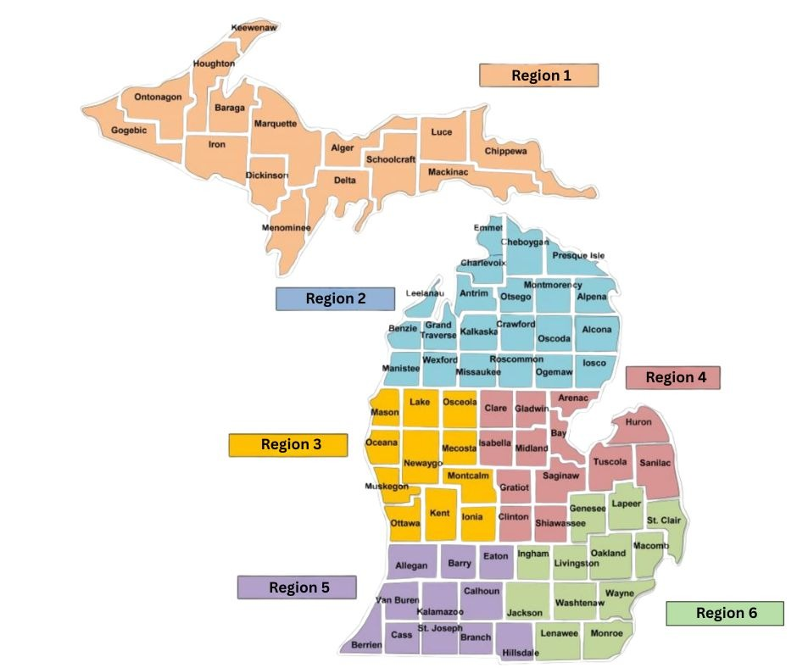

Michigan 4-H Dairy Programming Committee
Committee Application Form
Thank you for your interest in serving on the Michigan 4-H Dairy Programming Committee. This committee works to support dairy youth development, strengthen educational programming, and provide guidance for statewide dairy initiatives within Michigan 4-H Youth Development.
Please complete all applicable sections of the application.

Applicant Information
Name (First & Last): ______________________________________
Preferred Name: _______________________________
Applicant Type:
☐ Youth Applicant
☐ Adult Applicant
Phone Number: _______________________________
Email Address: _______________________________
Home Address:
Street Address: __________________________________
City: __________________________
State: ________
Zip Code: __________

4-H Information
(Must complete by both youth and adult applicants)
Are you currently enrolled and approved in 4-H Online?
☐ Yes
☐ No
4-H County of Enrollment: ______________________________
Region Applying For:
☐ Region 1
☐ Region 2
☐ Region 3
☐ Region 4
☐ Region 5
☐ Region 6

Youth Applicant Section
(Complete only if applying as a youth member)
Current 4-H Age (As of January 1st, 2026): __________

Adult Applicant Section
(Complete only if applying as an adult member)
Are you an approved Michigan 4-H Gold Level Volunteer?
☐ Yes
☐ No
Are you applying as the historical member of the committee?
☐ Yes
☐ No
How would you help ensure youth voice is represented in statewide dairy programming?

Short Answer Questions
(Each Question Below is Required for All Applicants)
1. Please describe your experience with dairy cattle and dairy programs (4-H, FFA, dairy judging, showing, dairy farm involvement, etc.).

2. Describe any leadership roles you have held in 4-H, school, agricultural organizations, or your community.

3. Why are you interested in serving on the Michigan 4-H Dairy Programming Committee?

4. What ideas or perspectives would you bring to help strengthen dairy programming for Michigan 4-H youth?

5. What skills or experiences make you a strong contributor to a committee environment (for example: teamwork, communication, planning events, mentoring youth, etc.)?

The selection committee reserves the right to ask applicants to submit references.
Applicant Signature
I certify that the information provided in this application is accurate.
Applicant Signature: __________________________________
Date: ________________
Parent/Guardian Signature (Youth Applicants Only): _____________________________________
Date: ________________ Please submit completed applications to Kendra at vanorde4@msu.edu

